What Influences your decision making

Q1. What are some of the factors that might influence your diagnosis when certifying a death?

Q2. What are some of the factors that might influence your diagnosis when deciding how to record that diagnosis on the medical certificate?

Q3. Are there any causes of death which you feel particularly uncomfortable recording on medical certificate?

Q4. Have you ever felt under pressure to either not record a cause on a medical certificate (or medical record) or to change something that you had earlier written?
- Without providing identifiable data, describe what happened: describe (loosely) the case – adult/ child etc), what was the cause of death, what were your concerns.

- What did you record on the certificate (as best as you remember)?

- Did you change the record?

- What was the source of the pressure (internal/ management/ family/ social/ church etc)? Was this implied or explicit?

- How did this make you feel?

Complete a certificate for the following cases:

Male, 55 years with a history of acute myocardial infarction two years before his death. From then, on he began to present with signs and symptoms of depression. The morning of the day of his death, he hung himself at home. He died at two o’clock in the afternoon of the same day in the hospital.

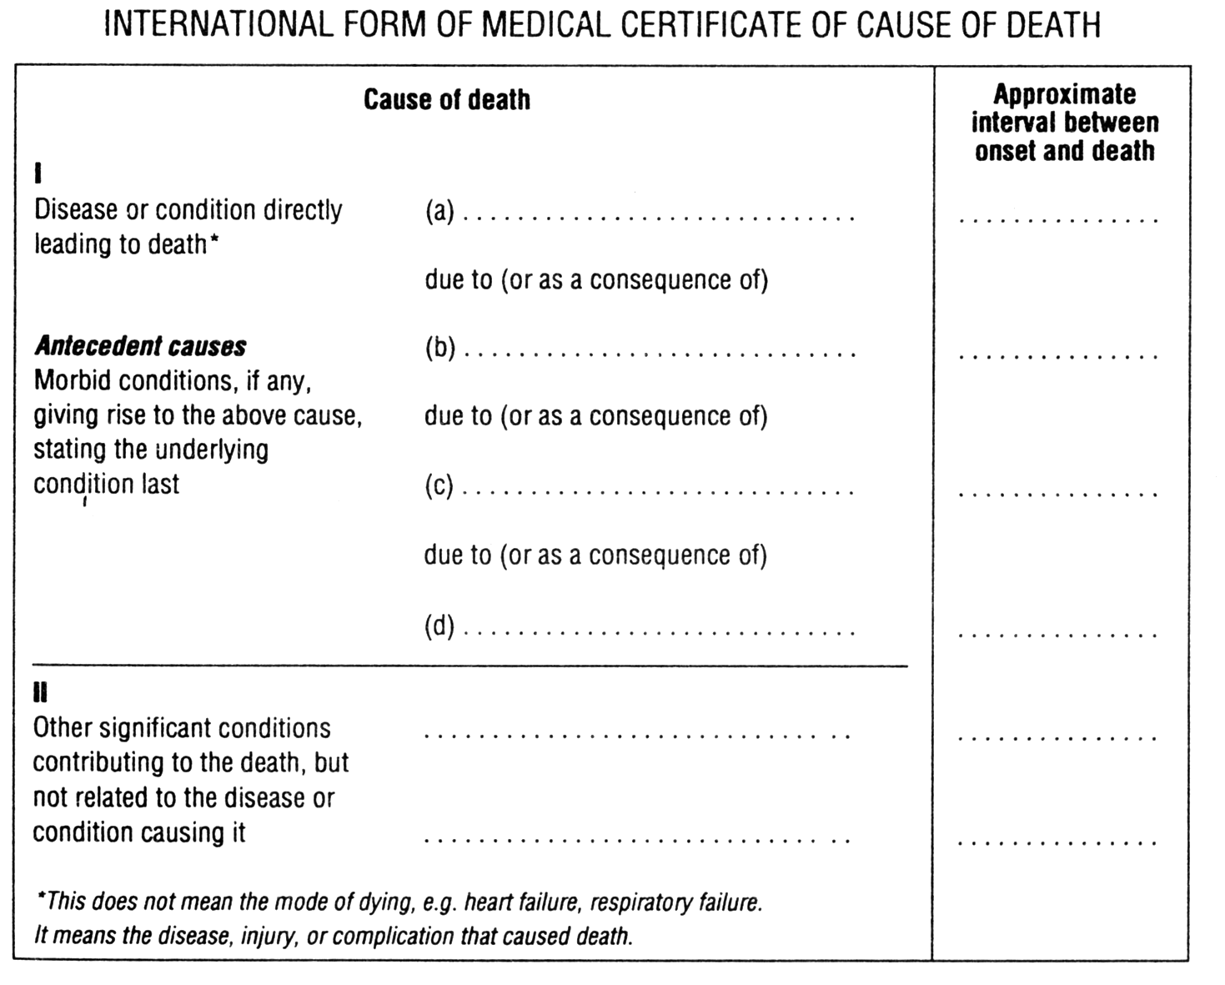

30 year old female presents with several skin lesions on her body, hypotension, tachycardia, and fever. Her condition worsened rapidly and she died. She has had chronic diarrhoea and weight loss for several months. Her lab was notable for a low white blood cell count. You suspect she may have had a complication due to HIV-AIDS.

40 year old male with alcoholic cirrhosis complicated by hepatic encephalopathy, ascites, esophageal varices presents to the hospital with massive gastrointestinal bleed. You suspect this is an upper GI bleed and that the cause of liver disease was secondary to alcohol. The family adamantly denies the patient has a history of alcohol use.

Note: Credit to Dr Nancy Vu for these case studies

