Sex:

Age: DOB:

DOD: TOD:

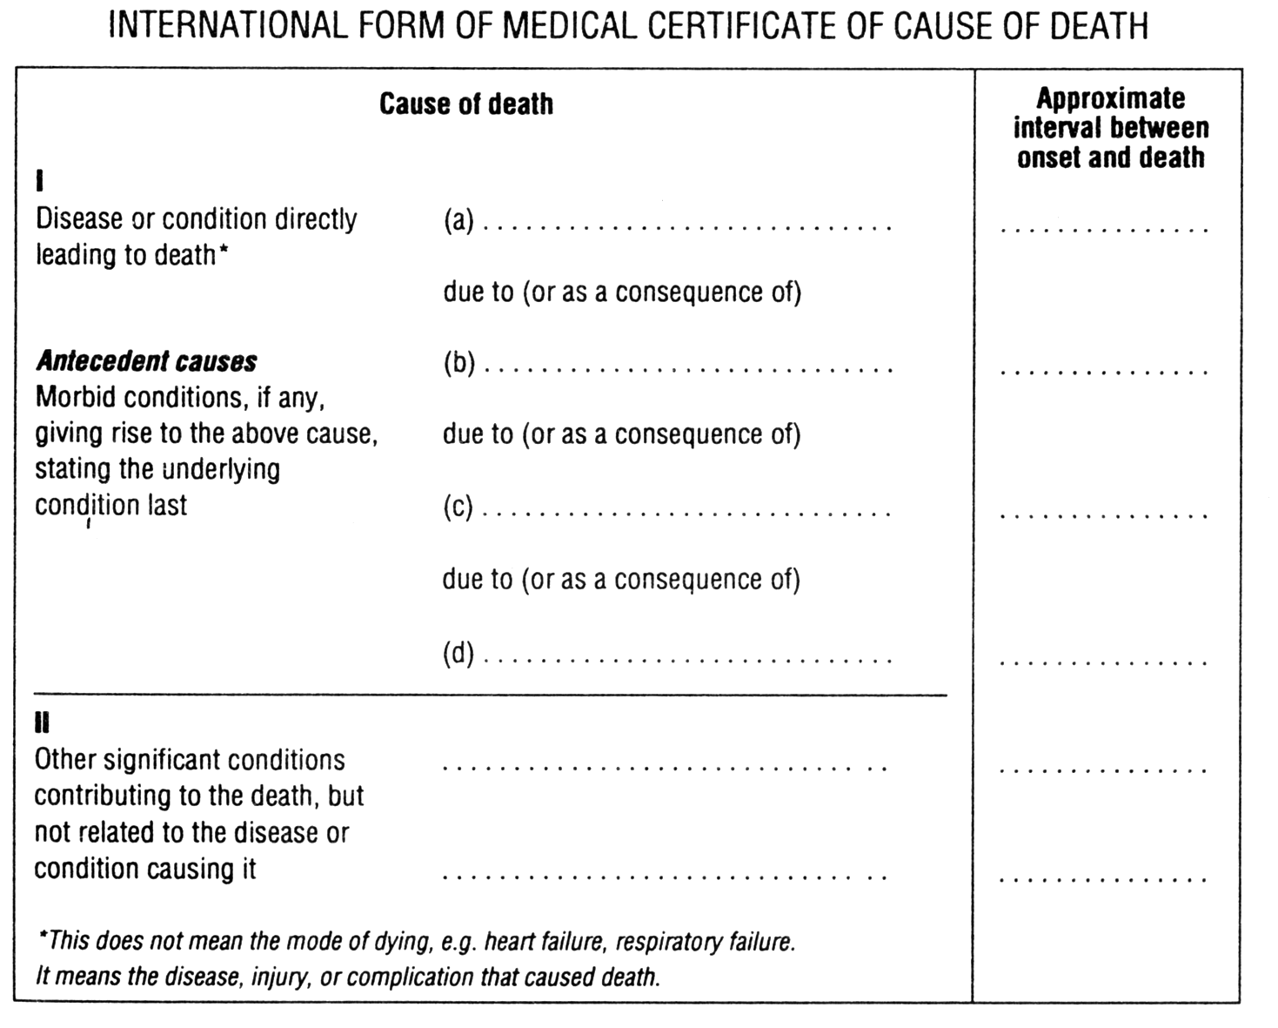

Certifying doctor:

Sex:

Age: DOB:

DOD: TOD:

Certifying doctor:

