Medical Uncertainty: Theatre play!

Case: This person is about to die from a “sudden death”
The case should keep their actual cause of death to themselves.
Doctor(s): You should allocate an attending physician (s) who will certify the case and a treating physician. Provide the attending physician(s) with a medical certificate to complete.
Family: The case should have one or two family members that accompany them to the hospital.
Friends:
Health Record Manager:
Medical Supervisor:

The case is about to die from a “sudden death” on the way to the hospital.
What is known is that the case went to sleep as normal last night. They were difficult to rouse this morning and unresponsive to stimuli. The family became concerned and drove the case to hospital. The case was found to be DOA on arrival. Case is an adult between 30-40.

The attending doctor must step through the process of what they would do to complete the certificate. Act this out with the designated cast. Feel free to prompt actions – ie check the medical record, discuss with the treating doctor, and interview family and friends. Each of these should add information as the case progresses.

Follow the progress of this investigation on the whiteboard.

At the end of the exercise – discuss the process and final certificate.

Consider – which sources of information are most reliable, are we certain about the diagnosis, how would we record uncertainty.

Discuss – how could these follow up actions be better incorporated into your practice?

Sex:

Age: DOB:

DOD: TOD:

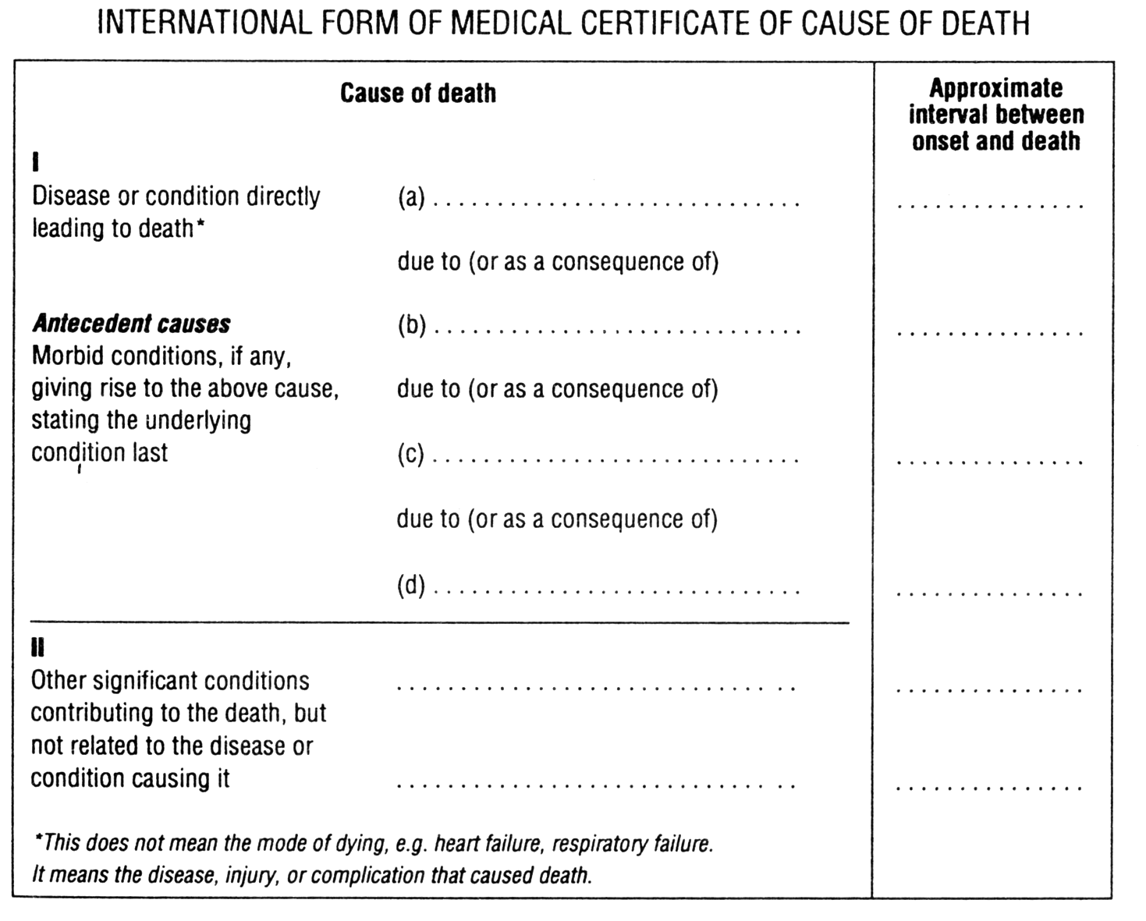

Certifying doctor:

