SPC/HOPS 2010/Information Paper 9
6 July 2010

ORIGINAL: ENGLISH

SECRETARIAT OF THE PACIFIC COMMUNITY

REGIONAL MEETING OF HEADS OF PLANNING AND HEADS OF STATISTICS (HOPS)
(Noumea, New Caledonia, 12–16 July 2010)

Statistics2020 – Developing sustainable national and regional statistical capacities

Session 4.4: Remote monitoring and control of census activities
(Document presented by the Secretariat of the Pacific Community)

PURPOSE

- This short paper outlines the use of remote monitoring technologies to assist SDP in providing technical support to counterparts in-country while working from Noumea (or on duty travel in another PICT).

- The paper describes how SDP support could be provided “remotely” for a range of other census and survey applications simultaneously, and why it is useful to consider this approach when planning future census ans survey activities.

BACKGROUND

- Providing technical support to a census or survey project can often mean a lot of time in-country. Sometimes countries run activities at the same time making it impossible to provide in-country technical support simultaneously, even for a well-staffed program. An ideal scenario would be whereby technical assistance is available almost instantaneously by an SPC staff member no matter where they are – particularly for mission critical work like census scanning.

- With the improvement of internet connections in the region it now becomes possible to use several technologies to provide remote assistance.

  - There are “peer-to-peer” applications such as Skype which allow people to communicate and transfer files with counterparts and colleagues in-country.
  - Remote control and desktop sharing applications like Teamviewer allow computers to be “remotely” controlled to fix problems, run checks after hours etc. Many IT professionals now use this kind of technology to provide remote assistance no matter where they are based.

There are several advantages with this “remote” approach:

- Continual technical support – no matter where the SDP staff member may be travelling.
- Easy transfer of data with “resume” functionality whereby users can disconnect/connect and the file transfer continues where it left off whenever there is a stable connection.
- Sharing of desktops – users at both ends can show each other their desktop. A bit like having someone sitting next to you moving your mouse and showing you what to do.
- Assistance can be provided to several countries at once
- Discussion history is saved – can easily go back and see how something was done a week ago.

SKYPE

- SDP currently uses Skype to communicate and transfer files with counterparts and colleagues in-country. Not only does this allow SPC staff to remain constantly in contact, but this can also mean an SDP Demographer travelling in Tonga, and a GIS Specialist in Noumea can both provide assistance to someone in the scanning room in the Solomon Islands through a “virtual” meeting or chat session. See figure 1.

Figure 1 : 3-way conversation using Skype

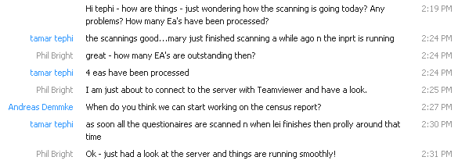

Files can easily be transferred over the network with resume support allowing a file transfer to work even in a country where internet connections are unreliable. Files as large as 5GB have been transferred between Honiara and Noumea over the space of about a week.

Figure 2 : File transfer using Skype

TEAMVIEWER

- Remote control technology has been tested by SDP for the first time with the Solomon Islands and Vanuatu censuses.

- A very light-weight Teamviewer application is installed on the server in-country and also on the machine of the person offering support. The software can be setup to allow permanent access by creating a password and access control that permits the remote user to log-in through windows. Assuming the server is always turned on, and the internet is connected this means 24-hour access.

Figure 3 : Logging-in to remote computer

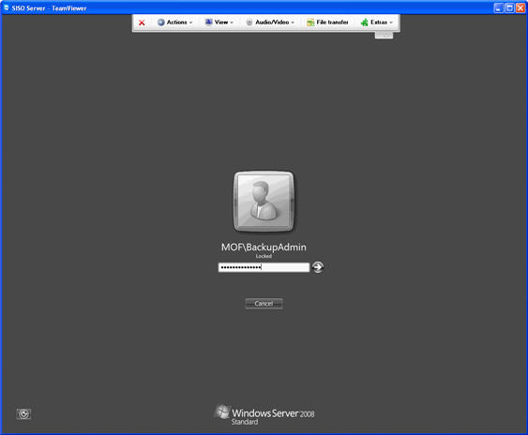

- Over the Teamviewer connection, various applications can be run, files zipped, deleted etc. Figure 4 illustrate the use of Skype on the server to transfer files, while ProductionInfo shows the number of forms scanned, interpreted and verified in a given day, and there is even the ability to have a chat session within the TeamViewer environment.

Figure 4 : Manipulating files using Teamviewer

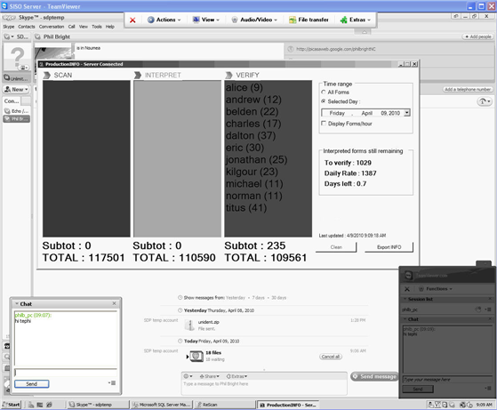

WHAT IS NEEDED TO ENABLE REMOTE SUPPORT?

- A dedicated internet connection is necessary in order for this technology to work. Considering the amount of money normally invested in technical support during a Census or Survey project, spending an extra several hundred dollars on a 12-18 month dedicated connection to the server is not a major additional expense. Ideally there would also be an internet connection to any other machines which will need to be controlled remotely (data processing machines) and to other computers involved in the manipulation of the data (if these computers are separate to those in the scanning room)

- Remote support applications need to be installed by both parties. Links to the websites for the two applications are below.
- http://www.teamviewer.com
- http://www.skype.com

There are other applications available providing the same assistance, but these two have been tried and tested, and they are FREE for non-commercial use.

DISCUSSION POINTS

- The meeting is invited to comment on:

- The usefulness of this technology for census and survey activities, as well as other activities within NSO’s.

ProductionINFO is a small application developed by SDP to assist the Scanning Team monitoring the scanning, interpreting and verifying of forms. There is an indication of a daily verify rate and an estimation of the number of days of processing remaining assuming an average throughput is adhered to.

