Case examples:

Case 1: Female, 66 years with mitral stenosis secondary to rheumatic heart disease. Five years ago she began to present with signs and symptoms of congestive cardiac failure and received medical treatment. At that time, she was noted to have hypertension, with measurements that ranged between 160-190 / 100-120. Her heart failure recently worsened and she presented to the hospital in decompensated heart failure, and the patient died soon after. (credit: N. Vu)

Part1: 1.
2.
3.
4.

Part 2:

Case 2: Female, 72 years with history of stroke with remaining hemiplegia, hypertension and recent operation for suspected cancer in the upper part of the stomach (not verified histo-pathologically) 10 months ago. One week before death, she presented with bronchopneumonia and found to have pulmonary metastases. Her clinical condition deteriorated, and she died during the same admission.
(credit: N. Vu)

Part1: 1.
2.
3.
4.

Part 2:

Extracts from Hawaii State training:

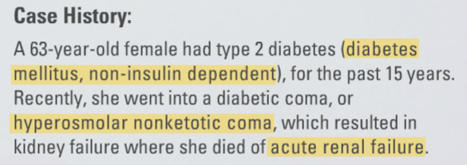

Part1: 1.
2.
3.
4.

Part 2:

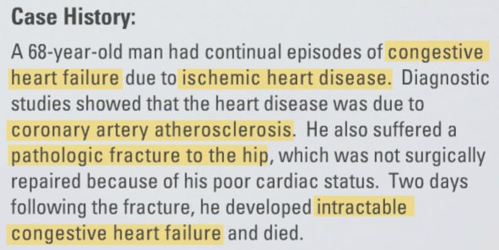

Part1: 1.
2.
3.
4.

Part 2:

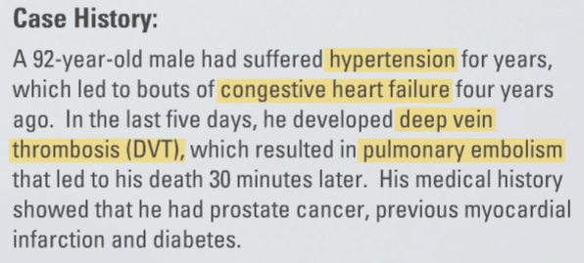

Part1: 1.
2.
3.
4.

Part 2:

